Execute Python Syntax
As we learned in the previous page, Python syntax can be executed by writing directly in the Command Line:
>>> print("Hello, World!")
Hello, World!
Or by creating a python file on the server, using the .py file extension, and running it in the Command Line:
C:\Users\Your Name>python myfile.py

Python Indentations
Where in other programming languages the indentation in code is for readability only, in Python the indentation is very important.
Python uses indentation to indicate a block of code.

Example
if 5 > 2:
print("Five is greater than two!")
Python will give you an error if you skip the indentation:

Example
if 5 > 2:
print("Five is greater than two!")

Comments
Python has commenting capability for the purpose of in-code documentation.
Comments start with a #, and Python will render the rest of the line as a comment:

Example
Comments in Python:
#This is a comment.
print("Hello, World!")

Docstrings
Python also has extended documentation capability, called docstrings.
Docstrings can be one line, or multiline.
Python uses triple quotes at the beginning and end of the docstring:

Example
Docstrings are also comments:
"""This is a
multiline docstring."""
print("Hello, World!")

Python Variables

Creating Variables
Unlike other programming languages, Python has no command for declaring a variable.
A variable is created the moment you first assign a value to it.

Example
x = 5
y = "John"
print(x)
print(y)
Variables do not need to be declared with any particular type and can even change type after they have been set.

Example
x = 4 # x is of type int
x = "Sally" # x is now of type str
print(x)

Variable Names
A variable can have a short name (like x and y) or a more descriptive name (age, carname, total_volume). Rules for Python variables:
- A variable name must start with a letter or the underscore character
- A variable name cannot start with a number
- A variable name can only contain alpha-numeric characters and underscores (A-z, 0-9, and _ )
- Variable names are case-sensitive (age, Age and AGE are three different variables)
Remember that variables are case-sensitive

Output Variables
The Python print statement is often used to output variables.
To combine both text and a variable, Python uses the + character:

Example
x = "awesome"
print("Python is " + x)
You can also use the + character to add a variable to another variable:

Example
x = "Python is "
y = "awesome"
z = x + y
print(z)
For numbers, the + character works as a mathematical operator:

Example
x = 5
y = 10
print(x + y)
If you try to combine a string and a number, Python will give you an error:

Example
x = 5
y = "John"
print(x + y)

Python Numbers
There are three numeric types in Python:
- int
- float
- complex
Variables of numeric types are created when you assign a value to them:

Example
x = 1 # int
y = 2.8 # float
z = 1j # complex
To verify the type of any object in Python, use the type() function:

Example
print(type(x))
print(type(y))
print(type(z))

Int
Int, or integer, is a whole number, positive or negative, without decimals, of unlimited length.

Example
Integers:
x = 1
y = 35656222554887711
z = -3255522
print(type(x))
print(type(y))
print(type(z))

Float
Float, or "floating point number" is a number, positive or negative, containing one or more decimals.

Example
Floats:
x = 1.10
y = 1.0
z = -35.59
print(type(x))
print(type(y))
print(type(z))
Float can also be scientific numbers with an "e" to indicate the power of 10.

Example
Floats:
x = 35e3
y = 12E4
z = -87.7e100
print(type(x))
print(type(y))
print(type(z))

Complex
Complex numbers are written with a "j" as the imaginary part:

Example
Complex:
x = 3+5j
y = 5j
z = -5j
print(type(x))
print(type(y))
print(type(z))

Python Casting

Specify a Variable Type
There may be times when you want to specify a type on to a variable. This can be done with casting. Python is an object-orientated language, and as such it uses classes to define data types, including its primitive types.
Casting in python is therefore done using constructor functions:
- int() - constructs an integer number from an integer literal, a float literal (by rounding down to the previous whole number), or a string literal (providing the string represents a whole number)
- float() - constructs a float number from an integer literal, a float literal or a string literal (providing the string represents a float or an integer)
- str() - constructs a string from a wide variety of data types, including strings, integer literals and float literals

Example
Integers:
x = int(1) # x will be 1
y = int(2.8) # y will be 2
z = int("3") # z will be 3

Example
Floats:
x = float(1) # x will be 1.0
y = float(2.8) # y will be 2.8
z = float("3") # z will be 3.0
w = float("4.2") # w will be 4.2

Example
Strings:
x = str("s1") # x will be 's1'
y = str(2) # y will be '2'
z = str(3.0) # z will be '3.0'

Python Strings

String Literals
String literals in python are surrounded by either single quotation marks, or double quotation marks.
'hello' is the same as "hello".
Strings can be output to screen using the print function. For example: print("hello").
Like many other popular programming languages, strings in Python are arrays of bytes representing unicode characters. However, Python does not have a character data type, a single character is simply a string with a length of 1. Square brackets can be used to access elements of the string.

Example
Get the character at position 1 (remember that the first character has the position 0):
a = "Hello, World!"
print(a[1])

Example
Substring. Get the characters from position 2 to position 5 (not included):
b = "Hello, World!"
print(b[2:5])

Example
The strip() method removes any whitespace from the beginning or the end:
a = " Hello, World! "
print(a.strip()) # returns "Hello, World!"

Example
The len() method returns the length of a string:
a = "Hello, World!"
print(len(a))

Example
The lower() method returns the string in lower case:
a = "Hello, World!"
print(a.lower())

Example
The upper() method returns the string in upper case:
a = "Hello, World!"
print(a.upper())

Example
The replace() method replaces a string with another string:
a = "Hello, World!"
print(a.replace("H", "J"))

Example
The split() method splits the string into substrings if it finds instances of the separator:
a = "Hello, World!"
print(a.split(",")) # returns ['Hello', ' World!']

Command-line String Input
Python allows for command line input.
That means we are able to ask the user for input.
The following example asks for the user's name, then, by using the input() method, the program prints the name to the screen:

Example
demo_string_input.py
print("Enter your name:")
x = input()
print("Hello, " + x)
Save this file as demo_string_input.py, and load it through the command line:
C:\Users\Your Name>python demo_string_input.py
Our program will prompt the user for a string:
Enter your name:
The user now enters a name:
Linus
Then, the program prints it to screen with a little message:
Hello, Linus

Python Operators
Operators are used to perform operations on variables and values.
Python divides the operators in the following groups:
- Arithmetic operators
- Assignment operators
- Comparison operators
- Logical operators
- Identity operators
- Membership operators
- Bitwise operators

Python Arithmetic Operators
Arithmetic operators are used with numeric values to perform common mathematical operations:
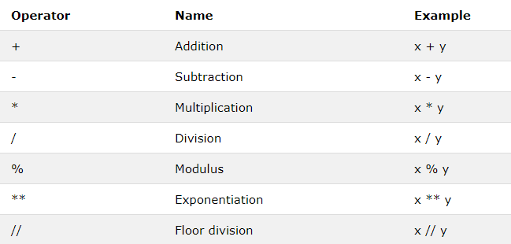

Python Assignment Operators
Assignment operators are used to assign values to variables:
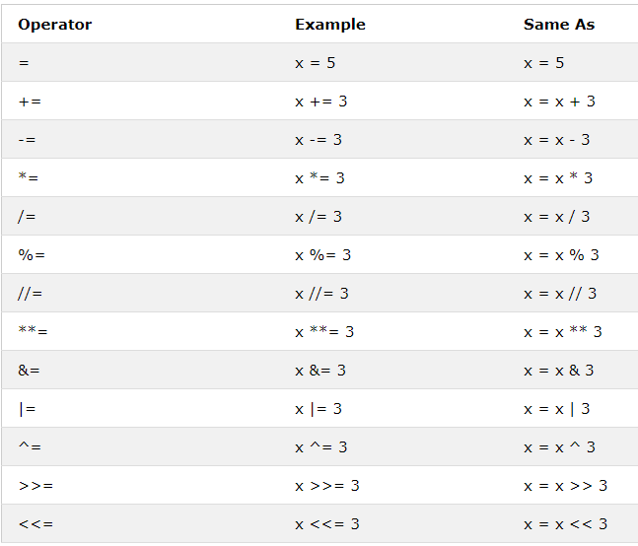

Python Comparison Operators
Comparison operators are used to compare two values:
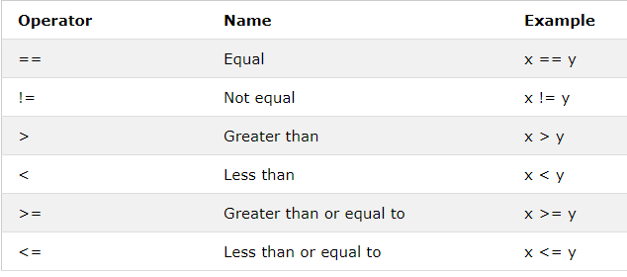

Python Logical Operators
Logical operators are used to combine conditional statements:
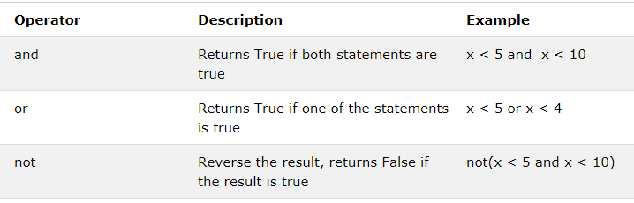

Python Identity Operators
Identity operators are used to compare the objects, not if they are equal, but if they are actually the same object, with the same memory location:
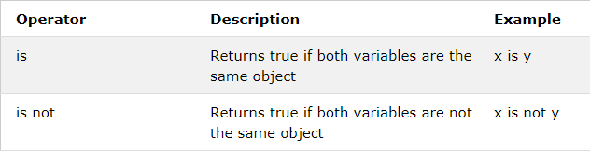

Python Membership Operators
Membership operators are used to test if a sequence is presented in an object:
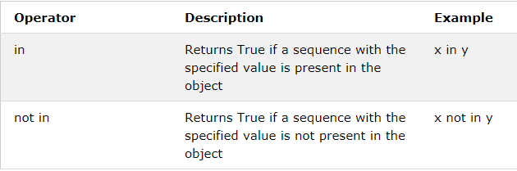

Python Bitwise Operators
Logical operators are used to combine conditional statements:
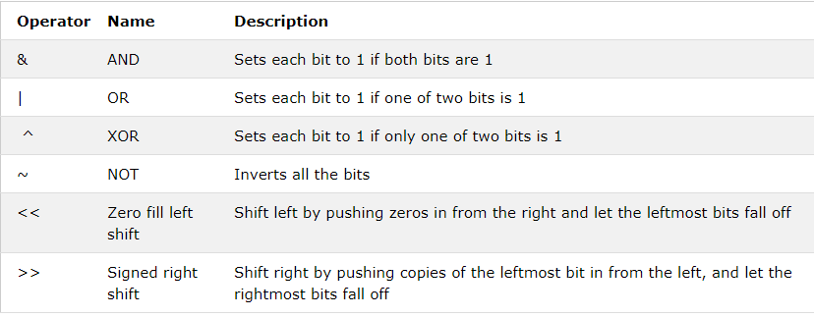

Python Lists

Python Collections (Arrays)
There are four collection data types in the Python programming language:
- List is a collection which is ordered and changeable. Allows duplicate members.
- Tuple is a collection which is ordered and unchangeable. Allows duplicate members.
- Set is a collection which is unordered and unindexed. No duplicate members.
- Dictionary is a collection which is unordered, changeable and indexed. No duplicate members.
When choosing a collection type, it is useful to understand the properties of that type. Choosing the right type for a particular data set could mean retention of meaning, and, it could mean an increase in efficiency or security.

List
A list is a collection which is ordered and changeable. In Python lists are written with square brackets.

Example
Create a List:
thislist = ["apple", "banana", "cherry"]
print(thislist)

Access Items
You access the list items by referring to the index number:

Example
Print the second item of the list:
thislist = ["apple", "banana", "cherry"]
print(thislist[1])

Change Item Value
To change the value of a specific item, refer to the index number:

Example
Change the second item:
thislist = ["apple", "banana", "cherry"]
thislist[1] = "blackcurrant"
print(thislist)

Loop Through a List
You can loop through the list items by using a for loop:

Example
Print all items in the list, one by one:
thislist = ["apple", "banana", "cherry"]
for x in thislist:
print(x)

List Length
To determine how many items a list have, use the len() method:

Example
Print the number of items in the list:
thislist = ["apple", "banana", "cherry"]
print(len(thislist))

Add Items
To add an item to the end of the list, use the append() method:

Example
Using the append() method to append an item:
thislist = ["apple", "banana", "cherry"]
thislist.append("orange")
print(thislist)
To add an item at the specified index, use the insert() method:

Example
Insert an item as the second position:
thislist = ["apple", "banana", "cherry"]
thislist.insert(1, "orange")
print(thislist)

Remove Item
There are several methods to remove items from a list:

Example
The remove() method removes the specified item:
thislist = ["apple", "banana", "cherry"]
thislist.remove("banana")
print(thislist)

Example
The pop() method removes the specified index, (or the last item if index is not specified):
thislist = ["apple", "banana", "cherry"]
thislist.pop()
print(thislist)

Example
The del keyword removes the specified index:
thislist = ["apple", "banana", "cherry"]
del thislist[0]
print(thislist)

Example
The del keyword can also delete the list completely:
thislist = ["apple", "banana", "cherry"]
del thislist
print(thislist) #this will cause an error because "thislist" no longer exists.

Example
The clear() method empties the list:
thislist = ["apple", "banana", "cherry"]
thislist.clear()
print(thislist)

The list() Constructor
It is also possible to use the list() constructor to make a list.

Example
Using the list() constructor to make a List:
thislist = list(("apple", "banana", "cherry")) # note the double round-brackets
print(thislist)

List Methods
Python has a set of built-in methods that you can use on lists.
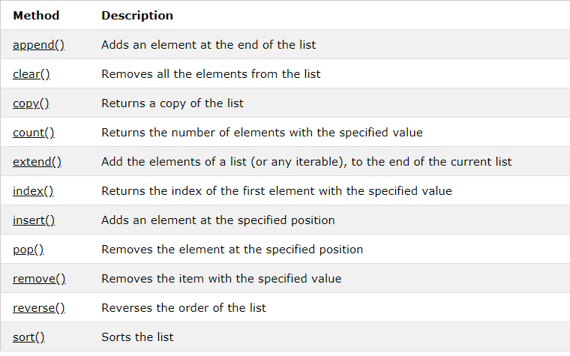

Python Tuples

Tuple
A tuple is a collection which is ordered and unchangeable. In Python tuples are written with round brackets.

Example
Create a Tuple:
thistuple = ("apple", "banana", "cherry")
print(thistuple)

Access Tuple Items
You can access tuple items by referring to the index number:

Example
Return the item in position 1:
thistuple = ("apple", "banana", "cherry")
print(thistuple[1])

Change Tuple Values
Once a tuple is created, you cannot change its values. Tuples are unchangeable.

Example
You cannot change values in a tuple:
thistuple = ("apple", "banana", "cherry")
thistuple[1] = "blackcurrant"
# The values will remain the same:
print(thistuple)

Loop Through a Tuple
You can loop through the tuple items by using a for loop.

Example
Iterate through the items and print the values:
thistuple = ("apple", "banana", "cherry")
for x in thistuple:
print(x)

Tuple Length
To determine how many items a list have, use the len() method:

Example
Print the number of items in the tuple:
thistuple = ("apple", "banana", "cherry")
print(len(thistuple))

Add Items
Once a tuple is created, you cannot add items to it. Tuples are unchangeable.

Example
You cannot add items to a tuple:
thistuple = ("apple", "banana", "cherry")
thistuple[3] = "orange" # This will raise an error
print(thistuple)

Remove Items
Note: You cannot remove items in a tuple.
Tuples are unchangeable, so you cannot remove items from it, but you can delete the tuple completely:

Example
The del keyword can delete the tuple completely:
thistuple = ("apple", "banana", "cherry")
del thistuple
print(thistuple) #this will raise an error because the tuple no longer exists

The tuple() Constructor
It is also possible to use the tuple() constructor to make a tuple.

Example
Using the tuple() method to make a tuple:
thistuple = tuple(("apple", "banana", "cherry")) # note the double round-brackets
print(thistuple)

Tuple Methods
Python has two built-in methods that you can use on tuples.
Method | Description
count() | Returns the number of times a specified value occurs in a tuple
index() | Searches the tuple for a specified value and returns the position of where it was found

Python Sets

Set
A set is a collection which is unordered and unindexed. In Python sets are written with curly brackets.

Example
Create a Set:
thisset = {"apple", "banana", "cherry"}
print(thisset)
Note: Sets are unordered, so the items will appear in a random order.

Access Items
You cannot access items in a set by referring to an index, since sets are unordered the items has no index.
But you can loop through the set items using a for loop, or ask if a specified value is present in a set, by using the in keyword.

Example
Loop through the set, and print the values:
thisset = {"apple", "banana", "cherry"}
for x in thisset:
print(x)

Example
Check if "banana" is present in the set:
thisset = {"apple", "banana", "cherry"}
print("banana" in thisset)

Change Items
Once a set is created, you cannot change its items, but you can add new items.

Add Items
To add one item to a set use the add() method.
To add more than one item to a set use the update() method.

Example
Add an item to a set, using the add() method:
thisset = {"apple", "banana", "cherry"}
thisset.add("orange")
print(thisset)

Example
Add multiple items to a set, using the update() method:
thisset = {"apple", "banana", "cherry"}
thisset.update(["orange", "mango", "grapes"])
print(thisset)

Get the Length of a Set
To determine how many items a set have, use the len() method.

Example
Get the number of items in a set:
thisset = {"apple", "banana", "cherry"}
print(len(thisset))

Remove Item
To remove an item in a set, use the remove(), or the discard() method.

Example
Remove "banana" by using the remove() method:
thisset = {"apple", "banana", "cherry"}
thisset.remove("banana")
print(thisset)
Note: If the item to remove does not exist, remove() will raise an error.

Example
Remove "banana" by using the discard() method:
thisset = {"apple", "banana", "cherry"}
thisset.discard("banana")
print(thisset)
Note: If the item to remove does not exist, discard() will NOT raise an error.
You can also use the pop(), method to remove an item, but this method will remove the last item. Remember that sets are unordered, so you will not know what item that gets removed.
The return value of the pop() method is the removed item.

Example
Remove the last item by using the pop() method:
thisset = {"apple", "banana", "cherry"}
x = thisset.pop()
print(x)
print(thisset)

Example
The clear() method empties the set:
thisset = {"apple", "banana", "cherry"}
thisset.clear()
print(thisset)

Example
The del keyword will delete the set completely:
thisset = {"apple", "banana", "cherry"}
del thisset
print(thisset)

The set() Constructor
It is also possible to use the set() constructor to make a set.

Example
Using the set() constructor to make a set:
thisset = set(("apple", "banana", "cherry")) # note the double round-brackets
print(thisset)

Set Methods
Python has a set of built-in methods that you can use on sets.

Set Methods
Python has a set of built-in methods that you can use on sets.
Method | Description
add() | Adds an element to the set
clear() | Removes all the elements from the set
copy() | Returns a copy of the set
difference() | Returns a set containing the difference between two or more sets
difference_update() | Removes the items in this set that are also included in another, specified set
discard() | Remove the specified item
intersection() | Returns a set, that is the intersection of two other sets
intersection_update() | Removes the items in this set that are not present in other, specified set(s)
isdisjoint() | Returns whether two sets have a intersection or not
issubset() | Returns whether another set contains this set or not
issuperset() | Returns whether this set contains another set or not
pop() | Removes the specified element
remove() | Removes the specified element
symmetric_difference() | Returns a set with the symmetric differences of two sets
symmetric_difference_update() | inserts the symmetric differences from this set and another
union() | Return a set containing the union of sets
update() | Update the set with the union of this set and others

Python Dictionaries

Dictionary
A dictionary is a collection which is unordered, changeable and indexed. In Python dictionaries are written with curly brackets, and they have keys and values.

Example
Create and print a dictionary:
thisdict = {
"brand": "Ford",
"model": "Mustang",
"year": 1964
}
print(thisdict)

Accessing Items
You can access the items of a dictionary by referring to its key name:

Example
Get the value of the "model" key:
x = thisdict["model"]
There is also a method called get() that will give you the same result:

Example
Get the value of the "model" key:
x = thisdict.get("model")

Change Values
You can change the value of a specific item by referring to its key name:

Example
Change the "year" to 2018:
thisdict = {
"brand": "Ford",
"model": "Mustang",
"year": 1964
}
thisdict["year"] = 2018

Loop Through a Dictionary
You can loop through a dictionary by using a for loop.
When looping through a dictionary, the return value are the keys of the dictionary, but there are methods to return the values as well.

Example
Print all key names in the dictionary, one by one:
for x in thisdict:
print(x)

Example
Print all values in the dictionary, one by one:
for x in thisdict:
print(thisdict[x])

Example
You can also use the values() function to return values of a dictionary:
for x in thisdict.values():
print(x)

Example
Loop through both keys and values, by using the items() function:
for x, y in thisdict.items():
print(x, y)

Dictionary Length
To determine how many items (key-value pairs) a dictionary have, use the len() method.

Example
Print the number of items in the dictionary:
print(len(thisdict))

Adding Items
Adding an item to the dictionary is done by using a new index key and assigning a value to it:

Example
thisdict = {
"brand": "Ford",
"model": "Mustang",
"year": 1964
}
thisdict["color"] = "red"
print(thisdict)

Removing Items
There are several methods to remove items from a dictionary:

Example
The del keyword removes the item with the specified key name:
thisdict = {
"brand": "Ford",
"model": "Mustang",
"year": 1964
}
del thisdict["model"]
print(thisdict)

Example
The pop() method removes the item with the specified key name:
thisdict = {
"brand": "Ford",
"model": "Mustang",
"year": 1964
}
thisdict.pop("model")
print(thisdict)

Example
The popitem() method removes the last inserted item (in versions before 3.7, a random item is removed instead):
thisdict = {
"brand": "Ford",
"model": "Mustang",
"year": 1964
}
thisdict.popitem()
print(thisdict)

Example
The del keyword removes the item with the specified key name:
thisdict = {
"brand": "Ford",
"model": "Mustang",
"year": 1964
}
del thisdict["model"]
print(thisdict)

Example
The clear() keyword empties the dictionary:
thisdict = {
"brand": "Ford",
"model": "Mustang",
"year": 1964
}
thisdict.clear()
print(thisdict)

The dict() Constructor
It is also possible to use the dict() constructor to make a dictionary:

Example
thisdict = dict(brand="Ford", model="Mustang", year=1964)
# note that keywords are not string literals
# note the use of equals rather than colon for the assignment
print(thisdict)

Dictionary Methods
Python has a set of built-in methods that you can use on dictionaries.
Method | Description
clear() | Removes all the elements from the dictionary
copy() | Returns a copy of the dictionary
fromkeys() | Returns a dictionary with the specified keys and values
get() | Returns the value of the specified key
items() | Returns a list containing the a tuple for each key value pair
keys() | Returns a list contianing the dictionary's keys
pop() | Removes the element with the specified key
popitem() | Removes the last inserted key-value pair
setdefault() | Returns the value of the specified key. If the key does not exist: insert the key, with the specified value
update() | Updates the dictionary with the specified key-value pairs
values() | Returns a list of all the values in the dictionary

Python If ... Else

Python Conditions and If statements
Python supports the usual logical conditions from mathematics:
- Equals: a == b
- Not Equals: a != b
- Less than: a < b
- Less than or equal to: a <= b
- Greater than: a > b
- Greater than or equal to: a >= b
These conditions can be used in several ways, most commonly in "if statements" and loops.
An "if statement" is written by using the if keyword.

Example
If statement:
a = 33
b = 200
if b > a:
print("b is greater than a")
In this example we use two variables, a and b, which are used as part of the if statement to test whether b is greater than a. As a is 33, and b is 200, we know that 200 is greater than 33, and so we print to screen that "b is greater than a".

Indentation
Python relies on indentation, using whitespace, to define scope in the code. Other programming languages often use curly-brackets for this purpose.

Example
If statement, without indentation (will raise an error):
a = 33
b = 200
if b > a:
print("b is greater than a") # you will get an error

Elif
The elif keyword is pythons way of saying "if the previous conditions were not true, then try this condition".

Example
a = 33
b = 33
if b > a:
print("b is greater than a")
elif a == b:
print("a and b are equal")
In this example a is equal to b, so the first condition is not true, but the elif condition is true, so we print to screen that "a and b are equal".

Else
The else keyword catches anything which isn't caught by the preceding conditions.

Example
a = 200
b = 33
if b > a:
print("b is greater than a")
elif a == b:
print("a and b are equal")
else:
print("a is greater than b")
In this example a is greater to b, so the first condition is not true, also the elif condition is not true, so we go to the else condition and print to screen that "a is greater than b".
You can also have an else without the elif:

Example
a = 200
b = 33
if b > a:
print("b is greater than a")
else:
print("b is not greater than a")

Short Hand If
If you have only one statement to execute, you can put it on the same line as the if statement.

Example
One line if statement:
if a > b: print("a is greater than b")

Short Hand If ... Else
If you have only one statement to execute, one for if, and one for else, you can put it all on the same line:

Example
One line if else statement:
print("A") if a > b else print("B")
You can also have multiple else statements on the same line:

Example
One line if else statement, with 3 conditions:
print("A") if a > b else print("=") if a == b else print("B")

And
The and keyword is a logical operator, and is used to combine conditional statements:

Example
Test if a is greater than b, AND if c is greater than a:
if a > b and c > a:
print("Both conditions are True")

Or
The or keyword is a logical operator, and is used to combine conditional statements:

Example
Test if a is greater than b, OR if a is greater than c:
if a > b or a > c:
print("At least one of the conditions are True")

Python While Loops

Python Loops
Python has two primitive loop commands:
- while loops
- for loops

The while Loop
With the while loop we can execute a set of statements as long as a condition is true.

Example
Print i as long as i is less than 6:
i = 1
while i < 6:
print(i)
i += 1
Note: remember to increment i, or else the loop will continue forever.
The while loop requires relevant variables to be ready, in this example we need to define an indexing variable, i, which we set to 1.

The break Statement
With the break statement we can stop the loop even if the while condition is true:

Example
Exit the loop when i is 3:
i = 1
while i < 6:
print(i)
if i == 3:
break
i += 1

The continue Statement
With the continue statement we can stop the current iteration, and continue with the next:

Example
Continue to the next iteration if i is 3:
i = 0
while i < 6:
i += 1
if i == 3:
continue
print(i)

Python For Loops

Python For Loops
A for loop is used for iterating over a sequence (that is either a list, a tuple, a dictionary, a set, or a string).
This is less like the for keyword in other programming language, and works more like an iterator method as found in other object-orientated programming languages.
With the for loop we can execute a set of statements, once for each item in a list, tuple, set etc.

Example
Print each fruit in a fruit list:
fruits = ["apple", "banana", "cherry"]
for x in fruits:
print(x)
The for loop does not require an indexing variable to set beforehand.

Looping Through a String
Even strings are iterable objects, they contain a sequence of characters:

Example
Loop through the letters in the word "banana":
for x in "banana":
print(x)

The break Statement
With the break statement we can stop the loop before it has looped through all the items:

Example
Exit the loop when x is "banana":
fruits = ["apple", "banana", "cherry"]
for x in fruits:
print(x)
if x == "banana":
break

Example
Exit the loop when x is "banana", but this time the break comes before the print:
fruits = ["apple", "banana", "cherry"]
for x in fruits:
if x == "banana":
break
print(x)

The continue Statement
With the continue statement we can stop the current iteration of the loop, and continue with the next:

Example
Do not print banana:
fruits = ["apple", "banana", "cherry"]
for x in fruits:
if x == "banana":
continue
print(x)

The range() Function
To loop through a set of code a specified number of times, we can use the range() function,
The range() function returns a sequence of numbers, starting from 0 by default, and increments by 1 (by default), and ends at a specified number.

Example
Using the range() function:
for x in range(6):
print(x)
Note that range(6) is not the values of 0 to 6, but the values 0 to 5.
The range() function defaults to 0 as a starting value, however it is possible to specify the starting value by adding a parameter: range(2, 6), which means values from 2 to 6 (but not including 6):

Example
Using the start parameter:
for x in range(2, 6):
print(x)
The range() function defaults to increment the sequence by 1, however it is possible to specify the increment value by adding a third parameter: range(2, 30, 3):

Example
Increment the sequence with 3 (default is 1):
for x in range(2, 30, 3):
print(x)

Else in For Loop
The else keyword in a for loop specifies a block of code to be executed when the loop is finished:

Example
Print all numbers from 0 to 5, and print a message when the loop has ended:
for x in range(6):
print(x)
else:
print("Finally finished!")

Nested Loops
A nested loop is a loop inside a loop.
The "inner loop" will be executed one time for each iteration of the "outer loop":

Example
Print each adjective for every fruit:
adj = ["red", "big", "tasty"]
fruits = ["apple", "banana", "cherry"]
for x in adj:
for y in fruits:
print(x, y)

Recursion
Python also accepts function recursion, which means a defined function can call itself.
Recursion is a common mathematical and programming concept. It means that a function calls itself. This has the benefit of meaning that you can loop through data to reach a result.
The developer should be very careful with recursion as it can be quite easy to slip into writing a function which never terminates, or one that uses excess amounts of memory or processor power. However, when written correctly recursion can be a very efficient and mathematically-elegant approach to programming.
In this example, tri_recursion() is a function that we have defined to call itself ("recurse"). We use the kvariable as the data, which decrements (-1) every time we recurse. The recursion ends when the condition is not greater than 0 (i.e. when it is 0).
To a new developer it can take some time to work out how exactly this works, best way to find out is by testing and modifying it.

Example
Recursion Example
def tri_recursion(k):
if(k>0):
result = k+tri_recursion(k-1)
print(result)
else:
result = 0
return result
print("\n\nRecursion Example Results")
tri_recursion(6)

